Day 2 Homework

Scenario 1
Steps 1 and 2:
Created a parent Group called IT Teams and added another Group called Developer and its parent is IT Teams
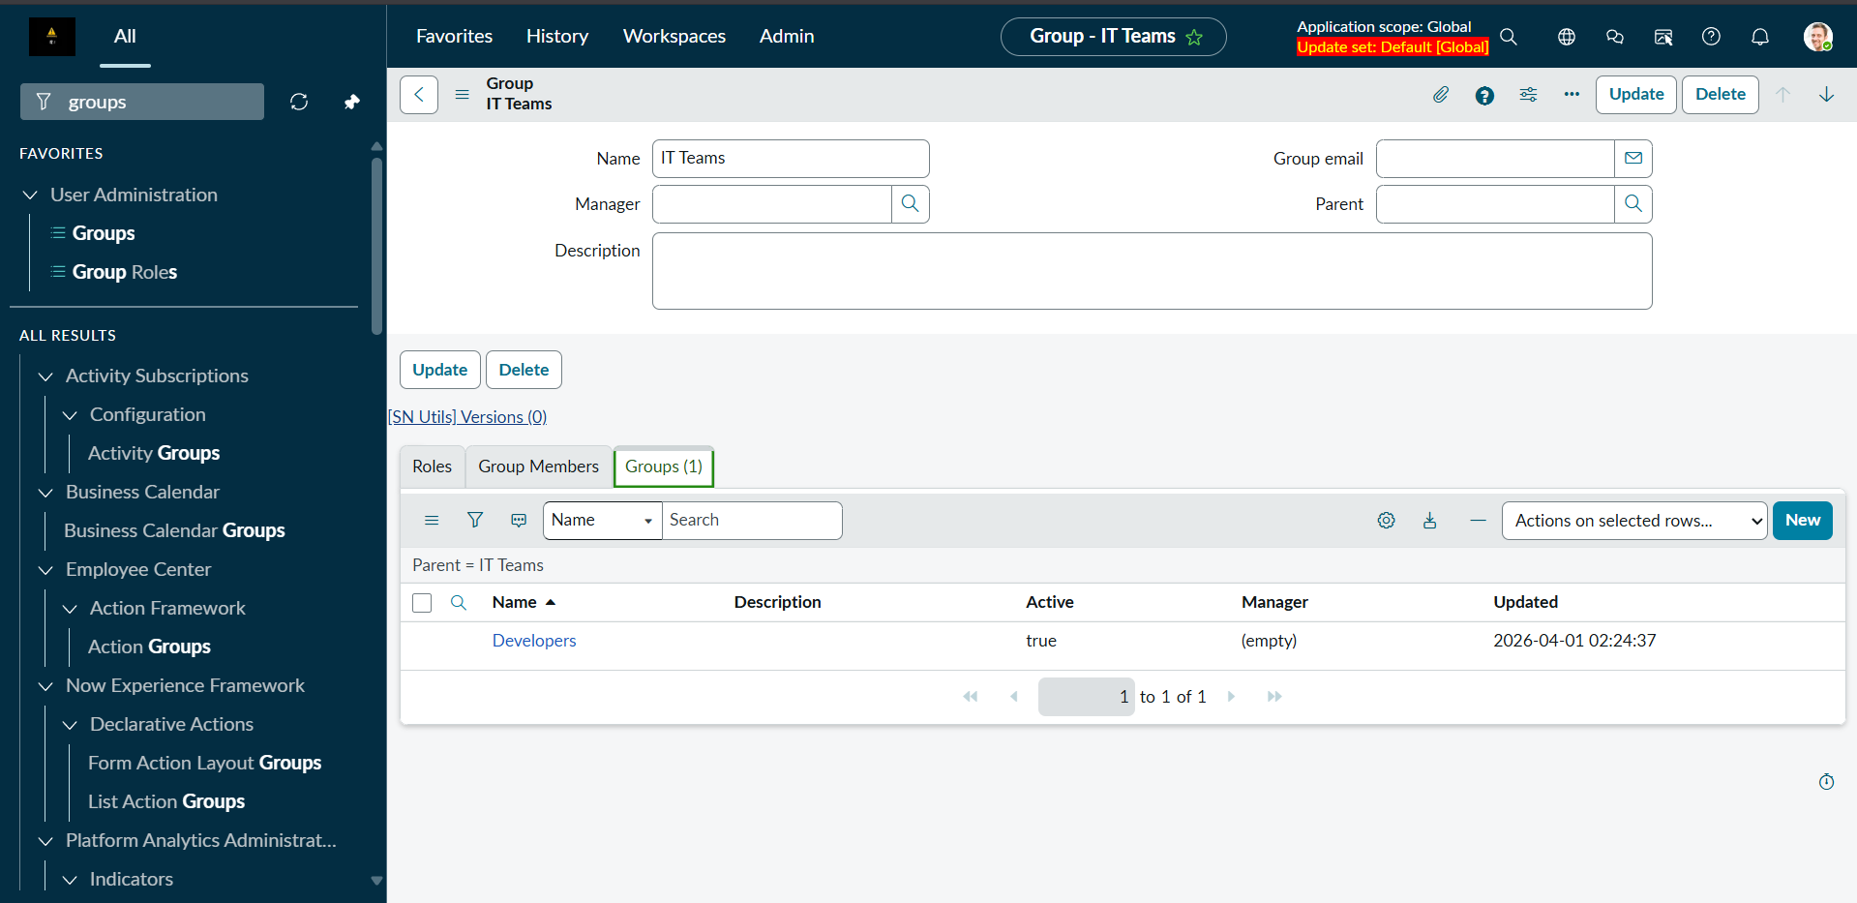

Stepss 3 and 4:
Created a new role called it_access_role and add it to IT teams group
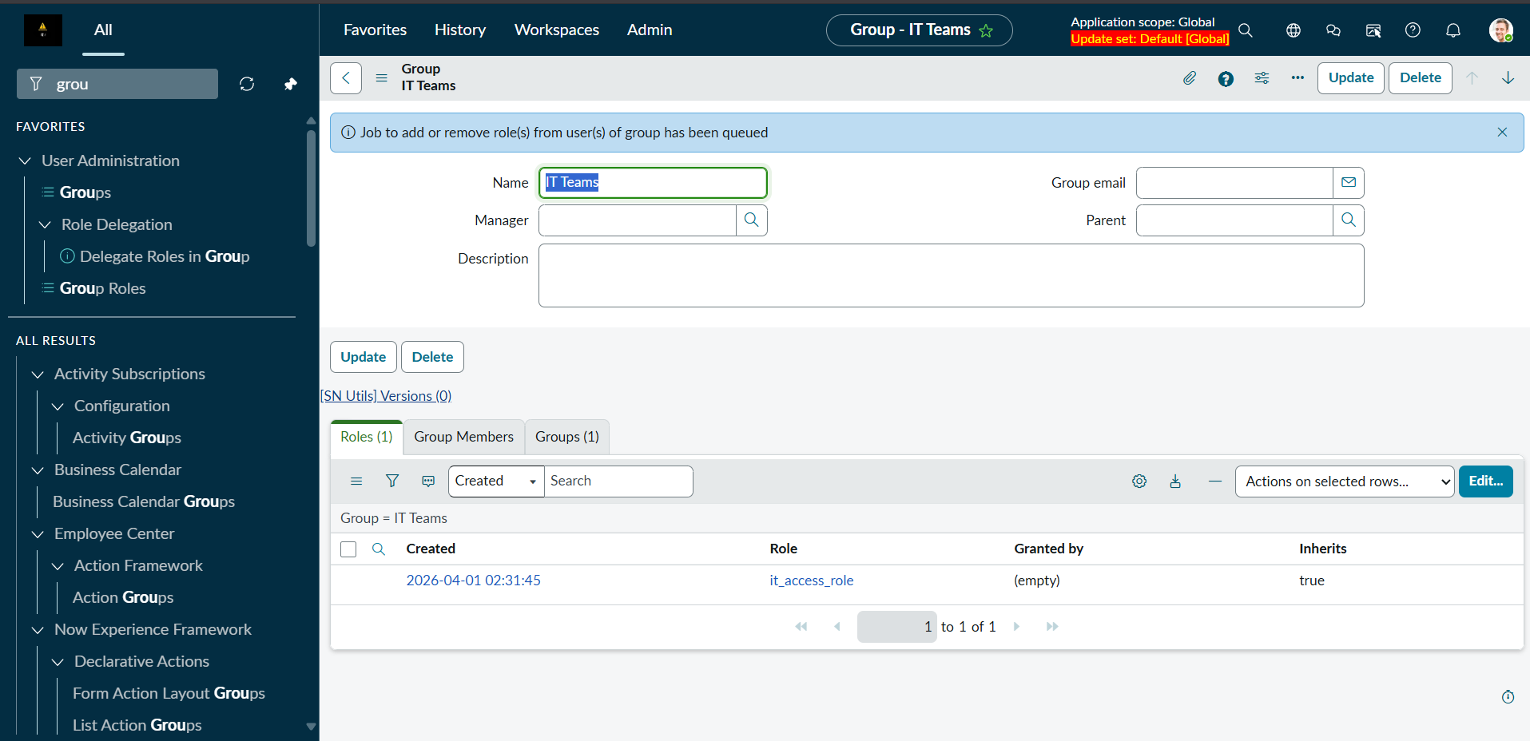
Step 5:
Added Rahul as a user and added him to developers group
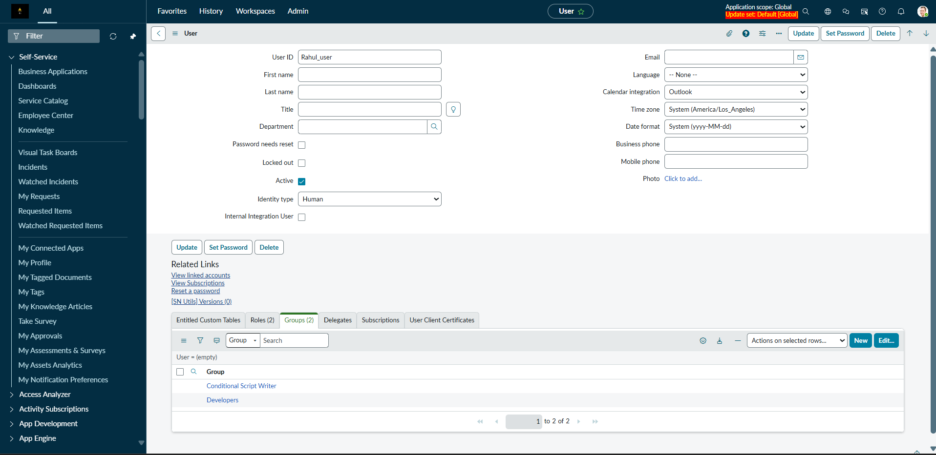

Scenario 2
Step 1:
Created two roles incident_role, change_role
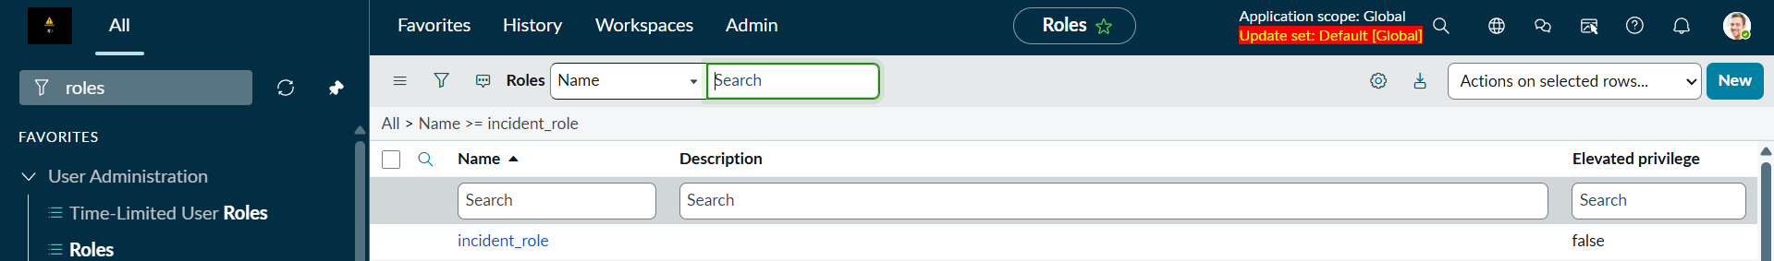
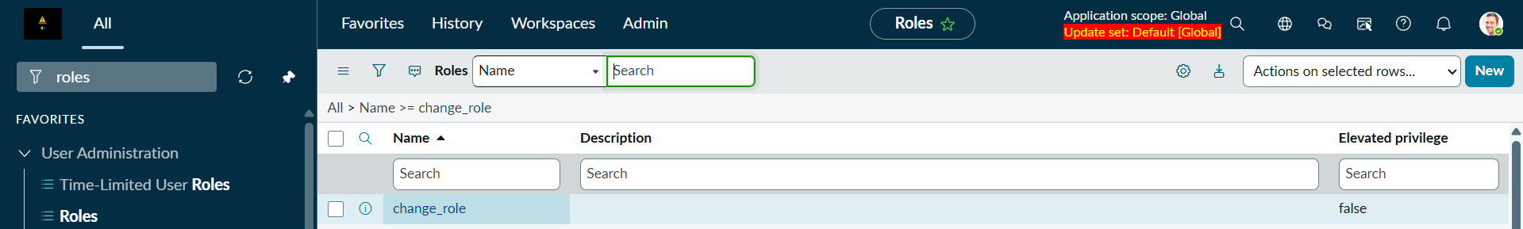
Steps 2 and 3:
Created a group called support team and added the previous two roles to a certain
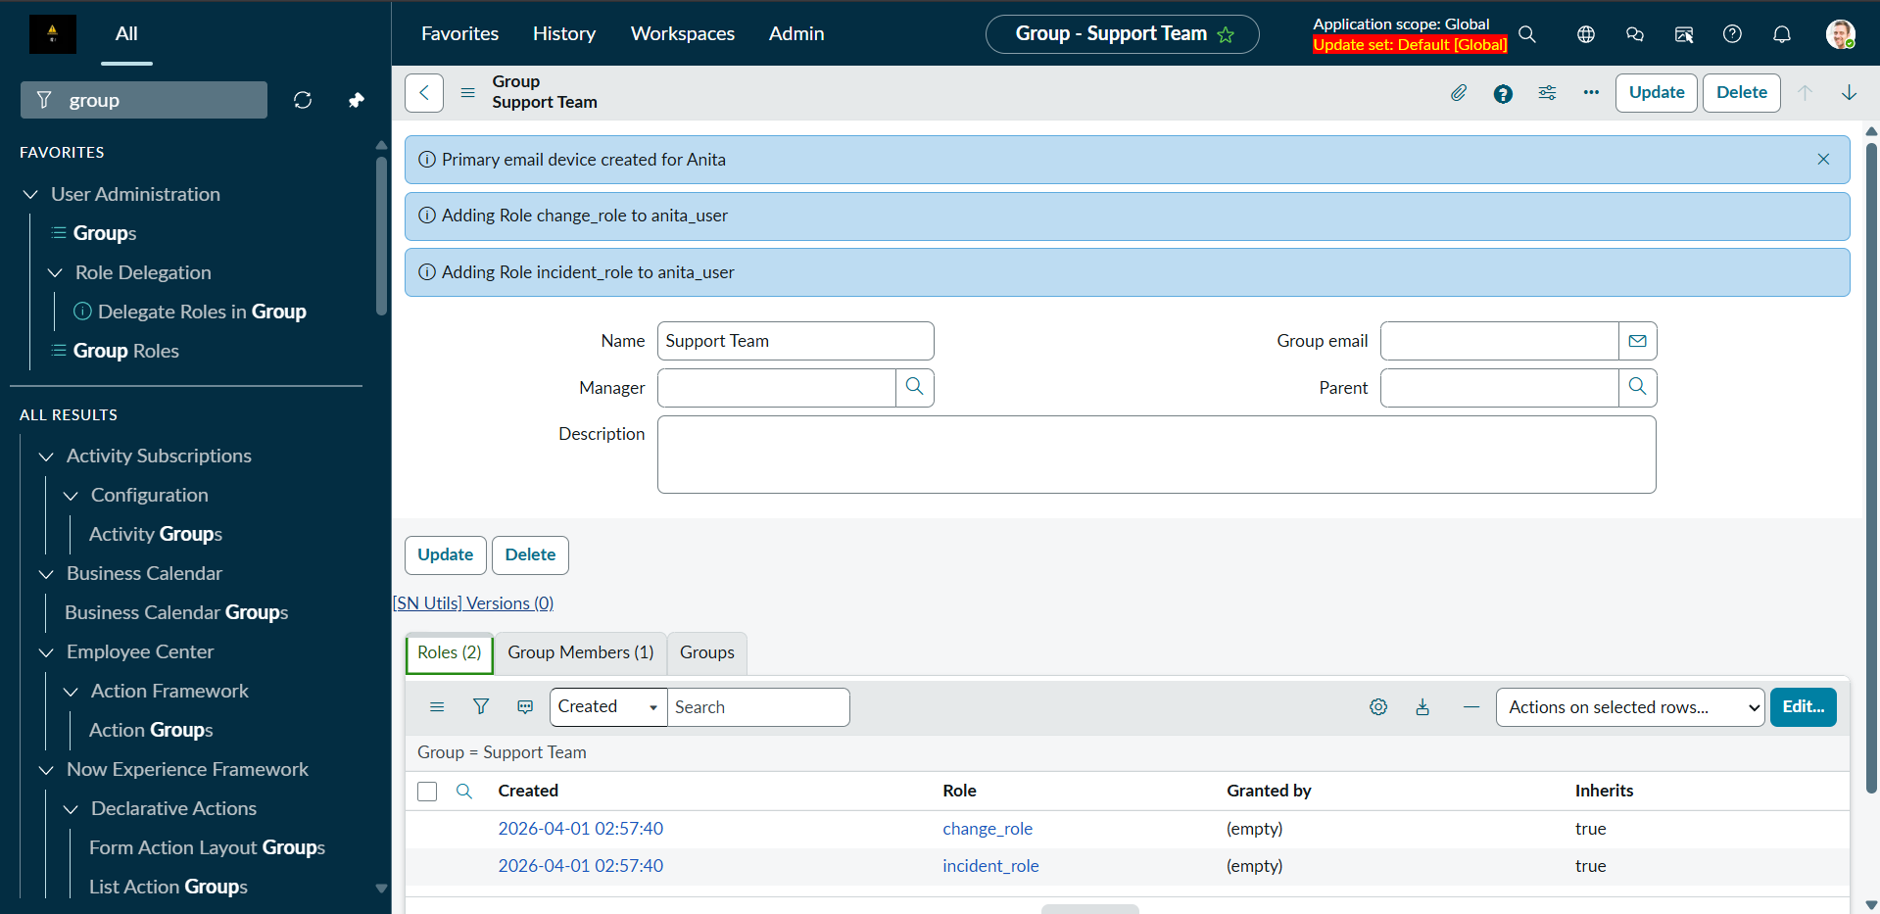
Step 5:
Created a user called Anita and added it to Support Team
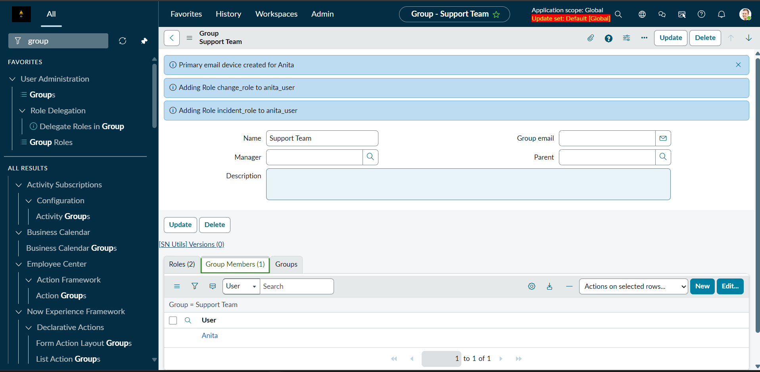

Scenario 3
Steps 1 and 2:
Created employee_role and manager_role and added employee role as a child of manager role
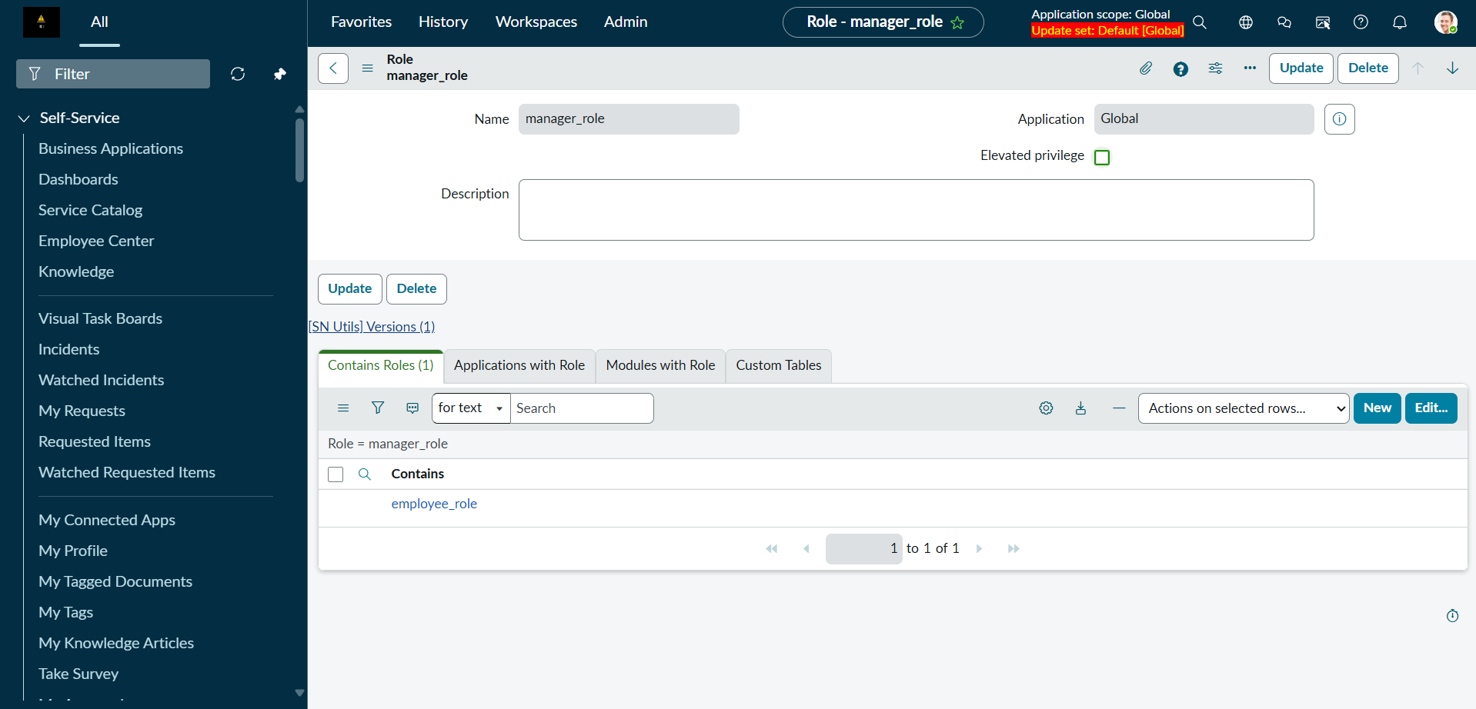
Step 3:
given a user named Suresh the manager_role
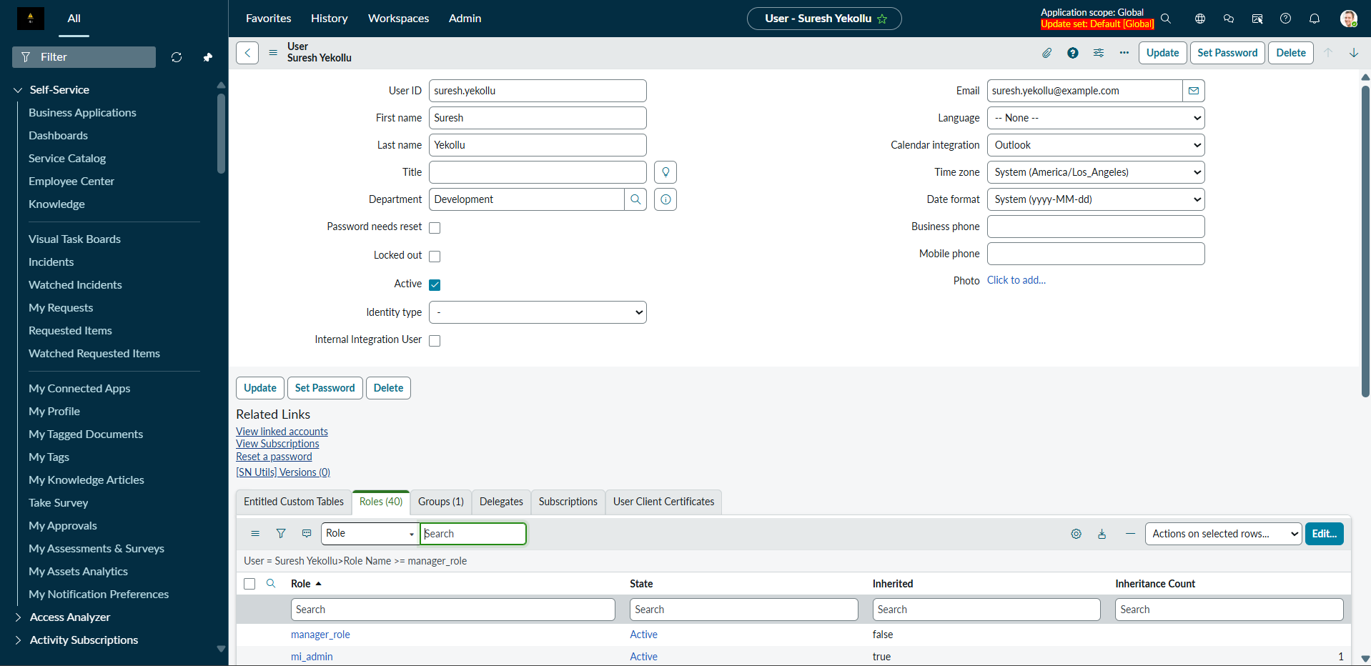

Scenario 4
Created Ravi and Amit, Amit is delegate for Ravi
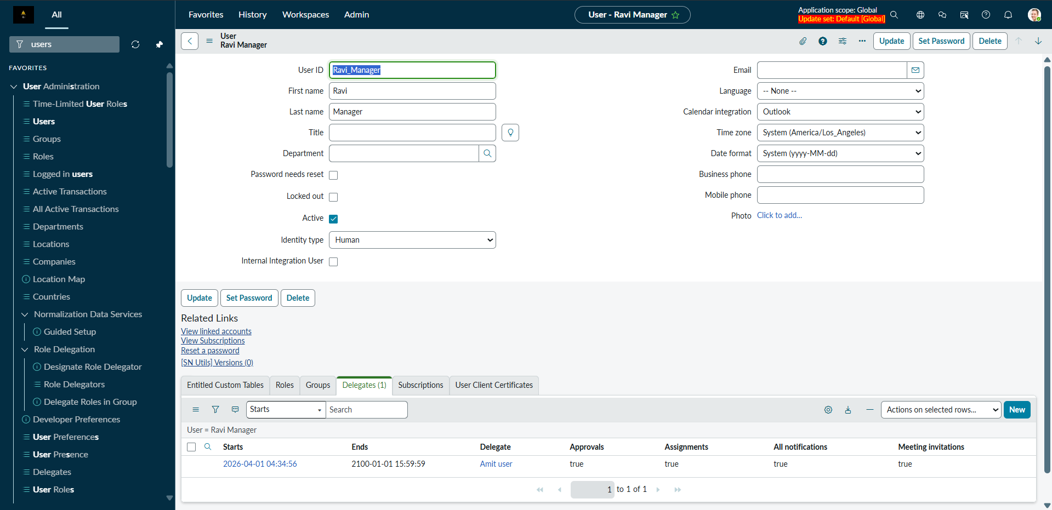

Scenario 6
Created Two Roles and created two group called HR group and Finance Group and also created two users named Pryia and Arjun and assigned each to one group
Finance Group and Arjun
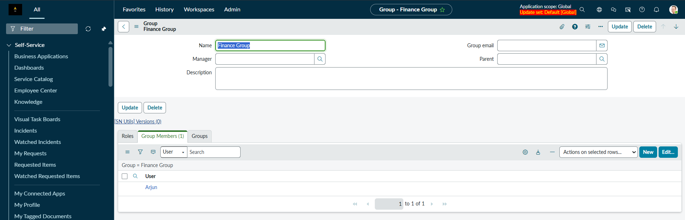
HR Group and Pryia
